Scott Morrison fails to persuade states to lower migration rate at Coag
The next migration cap likely to remain largely unchanged in the coming budget in April
Amy Remeikis @amyremeikis Wed 12 Dec 2018 19.08 AEDT Last modified on Wed 12 Dec 2018 19.10 AEDT

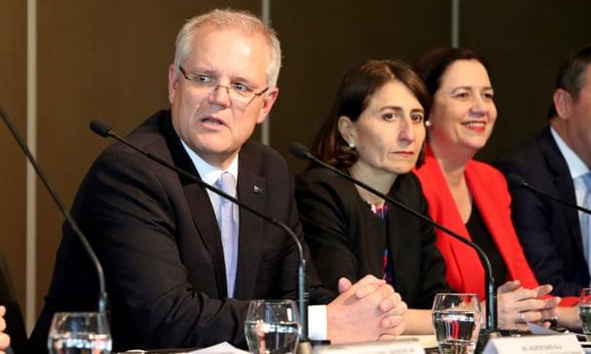
The prime minister, Scott Morrison, the NSW premier, Gladys Berejiklian, and the Queensland premier,
Annastacia Palaszczuk, at the Council of Australian Governments meeting. Photograph: Kelly Barnes/AAP
Population growth dominated Scott Morrison’s first meeting with state and territory leaders, causing smiles around the Council of Australian Governments (Coag) table but not in the way the prime minister might have imagined.
Morrison went into his first Coag as leader wanting to gain the states’ co-operation in lowering Australia’s migration rate and putting in more controls for where migrants would be allowed to settle.
The federal government, in response to growing voter frustration with congestion and infrastructure strain in Sydney and Melbourne, has proposed cutting Australia’s migration cap from 190,000 to 160,000. Just under 162,5000 people were accepted in Australia in the past year, under the current regime.
Only the New South Wales premier, Gladys Berejiklian, was on board before the meeting. And, after a presentation from population expert Prof Peter McDonald, where premiers and first ministers were told Australia’s current migration levels were needed, and attempts to confine migrants to particular areas would most likely fail, no further agreement was reached.
“There were smiles at that,” one person at the meeting said.
Outside, in a fairly congenial press conference by Coag standards, Morrison said the framework was still being worked out but the important thing was the discussion had begun.
“This will be an ongoing issue,” he said. “The next decision that has to be made, at least in terms of immigration, is what the annual intake cap will be for the 2019–20 year. And that decision is taken in the budget every year. That’s always been the case. So what I’ve sought from the states and territories is input and framing the intake for the next year and the cap.”
The Queensland premier, Annastacia Palaszczuk, was more blunt about McDonald’s presentation.
“I think he made a really good point about how more migration can go out to regional centres and we have a decentralised state,” she said. “And he said if the current birth rate of 1.8 births per family continues, and with the retirement of the baby boomer generation, we need to get skills not just from Australia but elsewhere.
“It has to be maintained, if not increased. That’s what I got out of the presentation.”
The ACT chief minister, Andrew Barr, also made a point of making “a clear statement of values that we think it is very important that Australia maintain a strong migration program”.
“This is very significant for the social, cultural and economic development of our nation,” he said. “And for many jurisdictions around the country. There is a need for increased population to drive economic activity but also to diversify the social and cultural base.
“In the national capital we will always be a proud refugee welcome zone and we will always be a jurisdiction that welcomes and values new migrants and international students for the role they play in our community.”
But the issue has effectively been kicked down the road, with the next migration cap likely to remain largely unchanged in the coming April budget.
There was agreement on managing infrastructure along with population growth, which the Victorian premier, Daniel Andrews, welcomed as a statement “in the clearest terms perhaps ever … that infrastructure and managing population growth are essentially the same issue”.
But, the rate of that growth remained fraught.
“It’s very clear now that we have a very different approach to issues regarding population state by state,” the South Australian premier, Steven Marshall, said. “There is no cookie-cutter approach. What we can do now is all work collaboratively towards a good strategy, a positive strategy which is going to ensure that we get population growth exactly where it’s needed in Australia going forward.”
The nuts and bolts of exactly how a new migration cap would work, and where those migrants may be sent, will form part of the next treasurers’ meeting.
But after several combative and hostile Coag meetings, led by disagreements over GST distribution which were finally resolved, the message from the nation’s leaders was cautiously optimistic at the conclusion of their December meeting.
“The progress made today was quite outstanding in terms of the number of issues that were covered,” Berejiklian said. “And all of our citizens in each of our jurisdictions will feel served by the agenda and the conclusions we’ve reached today from a very comprehensive agenda.
Issues surrounding national security and the drought were met with consensus, as was Queensland’s push for the “right to be forgotten” online for victims of cyberbullying.
Morrison has agreed to take it up at at commonwealth level, provided it did not interfere with the work of security agencies.
“We need to make sure, as we do this, we do not provide a loophole for those who might be engaged in all sorts of nefarious activities,” Morrison said, adding he would be furthering the talks at a later time.
The next time the state and territory leaders meet will be after the next federal election, in July, when it will be hosted by Queensland.
https://www.theguardian.com/australia-news/2018/dec/12/scott-morrison-fails-to-persuade-premiers-to-lower-migration-rate-at-coag

